AES Counseling Connection

**April 1, 2018**



Dear Parents,

Last month in counseling we spent time learning about the issue of fairness. Students learned that fairness means playing by the rules, sharing and taking turns, listening to both sides of an argument and trying to work out a compromise and speaking up when you see someone being treated unfairly. We also spent time discussing the difference between fair and equal. To sum that up, equal means everyone gets the same. Fair means that everyone gets what they need to succeed.

This month we are exploring the character trait of citizenship. This is one of our six pillars of character. Citizenship includes cooperating with others, obeying rules and laws, doing things to make our school and neighborhoods a better place and protecting the Earth.

**Continued**

Activities for students in our citizenship units will include discussions on the price of freedom and exercising our right to vote, ways we can make our communities a better place to live, and ways to protect the Earth. Earth Day is April 22nd and students will be encouraged to do small things for the Earth not only that day, but all throughout the month of April. Examples include not wasting water but turning it off when brushing teeth or not taking overly long showers; turning off the lights or tv when leaving a room; planting a tree, not littering and picking up trash and putting it in its proper place; and recycling. All of our efforts combined can make a difference in keeping our Earth clean and protecting it for future generations.

This month we also begin our standardized testing for the year with TN Ready. Teachers have been preparing students all year for these tests. I have included testing tips lessons with all grade levels this month. Here is a link that also has helpful tips for testing for parents.

<http://www.scholastic.com/parents/resources/article/study-skills-test-taking/standardized-tests-prepare-and-interpret-results>

DATES to remember:

April 2- REgular school day

April 3- Program of Study Fair at LA and parent meeting that night

April 17-27- TN Ready testing

april 30-may 3- 2nd grade testing

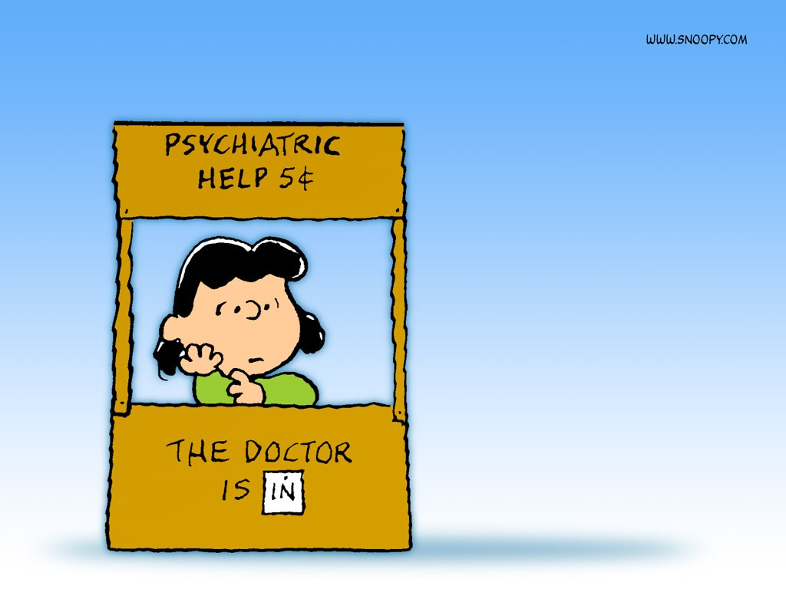

As always, thank you for allowing me the privilege of serving as your child’s counselor at AES. I am always available to talk with students or parents as you have need. Please contact me at school at 823-5921 or kaldridge@overtoncountyschools.net.

Mrs. Kerri Aldridge,

School Counselor