AES Counseling Connection

**August 1, 2017**



***Welcome back!***

Dear parents,

Welcome back to another year at Allons Elementary! We are so excited to begin a new year of learning with your child!

I would like to take this opportunity to introduce myself especially to our new families who may not have met me before. My name is Kerri Aldridge and I am the school counselor here at AES. This is my 14th year in our school as counselor. I have three counseling related degrees from Tennessee Technological University, a BS in Psychology, MA in School Psychology and EdS in School Counseling.

I love getting to work with our students. I provide weekly classroom lessons on character education, individual counseling and parent/teacher collaboration services.

**continued**

As a school counselor, I do NOT and CANNOT provide intensive therapy to students. I will typically see students for 1-3 sessions and if they need services beyond that, I will refer them to outside counseling services.

My goal as a counselor is to see our students succeed academically, personal/socially and then in career planning for their future. Each lesson that is presented in the classroom setting is standards based and aligned with the American School Counseling Model and Tennessee Model for School Counseling to assist in meeting these goals.

I look forward to working with your child, their teachers and you as we begin the new year. If you feel that your child would benefit from seeing me individually, please contact me either personally or by phone or email. We will talk about your concerns and see how we can best help your student. Teachers and administration also make referrals as well as students themselves.

Confidentiality is always important in establishing my relationships with the students. I will not tell what the student has talked with me about unless 1. They are being hurt; 2. They are hurting themselves; 3. They are going to hurt someone. But, I will encourage your child to share with you some things that we may have discussed so that you can also help them at home. This is important so that the students know that they can trust me with personal information and problems. If you have questions about our confidentiality policy, please contact me.

**Back to school tips**

Back to school can be a hectic time for everyone. Here are some tips to make the transition easier.

1. Visit the school. –Become familiar with the building and the faces of school personnel.
2. Introduce yourself to your child’s teacher. –Ask about the preferred method of communication and be involved!
3. Make homework a priority. –Make homework a daily habit. find a quiet and consistent place where your child can complete their homework. If your child is struggling, make an appointment with their teacher sooner rather than later.
4. Prepare a study area. –Set up a special place to do homework. remove distractions. Show interest and praise your child’s efforts to complete homework on time.
5. take charge of tv time. –Limit the time you let your child watch tv and monitor what they are watching.
6. get everyone to bed on time. –proper rest is essential for a healthy and productive school year. be consistent and get them back in routine as soon as possible.
7. make healthy meals or make sure that your child eats breakfast. - no one can focus when they are hungry. Either insure your child eats breakfast at home or eat at school.

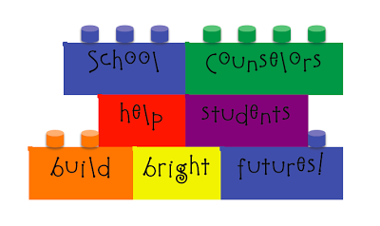

If we want our students to succeed, it will take all of us working together. This will be the only paper copy of my newsletter this year. If you are interested in keeping up with what’s happening with our school counseling program, please visit my school website at <http://aescounselingconnection.weebly.com>.

Thank you for the chance to work with you in making this year a great one for your child!

Sincerely,

Mrs. Kerri Aldridge

Allons Elementary School Counselor