AES Counseling Connection

**December 1, 2017**



Dear Parents,

December is always a busy time of year at school. I am sure you can relate at home as well. We have a shorter month in which to teach students and inevitably have field trips planned and programs to practice for and present to families. In the midst of all the “busyness” however, I still try to stay on track as much as possible with our counseling lessons.

This month students will learn what it means to be kind and caring. This character trait serves as a good review for respect and we spent many weeks on those lessons in the month of September.

Kind and caring students are those who show compassion to others. Compassion means sympathetic concern for the sufferings and misfortunes of others. This is an especially important trait to develop in children particularly in bullying situations. It allows the student to feel obligated to help the target of bullying behavior by intervening when safe or reporting to an adult who can help.

**Continued**

Kind and caring students also express gratitude. We just came out of the season of Thanksgiving, but, really we should live with an attitude of gratitude year round. Most of us have been blessed beyond measure and even those that struggle can still find reasons to be grateful for what they have. We should seek to develop this in our students as well.

Kind and caring students also forgive others. No doubt, we have all been wronged by someone at some point. However, carrying a grudge about what happened does nothing but hurt us more than the one who wronged us. Sometimes they may not even know that they did something. So, if possible, talk to them about how you feel and realize the power of forgiveness. Your heart will be lighter and you will be able to move on to better things.

The final trait of a kind and caring person is one who helps people in need. There are many in our world who need assistance. It could be financially or even emotionally. If possible, share some of what you have. There are numerous organizations that collect for those in need during the holiday season. Donate what you can. This bucket filling behavior will add to someone else’s bucket and also fill yours right up!

Sometimes we just need someone to care. Look for ways to show you care this holiday. Send a card, make a visit, sit with the lonely student…the list could go on and on. What matters is you take the time to make a difference in someone’s life.

If we put these things into practice this month and every month, our school will be a better place, which will spill over into our homes and our community. Let’s do our part to make a difference today.

**Dates to remember:**

**December 4th: Santa visits aes**

**december 5th: pto meeting 5:00**

**december 6th: 8th grade will attend the highlands career fair at hyder burks in cookeville**

**december 12th: Christmas program at school for k-4th grade students and families**

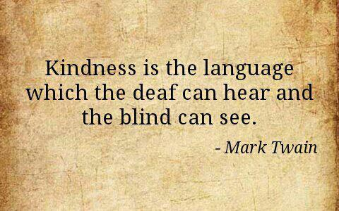

As always, thank you for allowing me the privilege of serving as your child’s counselor at AES. I am always available to talk with students or parents as you have need. Please contact me at school at 823-5921 or kaldridge@overtoncountyschools.net.

Mrs. Kerri Aldridge,

School Counselor