AES Counseling Connection

**February 1, 2018**



Dear Parents,

Last month in counseling your child spent time learning about the importance of setting goals and showing perseverance to reach those goals. They were taught that setting a SMART goal will lead them to success. SMART goals are S- specific, M- measurable, A- Achievable, R- Relevant and Results-focused, and T- Time bound. Each student was asked to choose a goal for the new year and work hard to achieve that goal. Students also learned the difference between long and short term goals.

This month, students will be focusing on one of their long term goals for their lives- careers. This is fun for them as they get to dream about “what they want to be when they grow up.” It may seem silly to begin talking about careers as early as Kindergarten, but, research has shown that career planning needs to begin even then. If students begin as early as Kindergarten learning about the importance of work and how it helps to meet our needs and wants

**Continued**

in life, then we can build on that foundation each year and help them discover careers that they are interested in and would like to pursue in the future.

Each grade level has lessons tailored specifically to them in career exploration. Early elementary will spend time on community helpers and dreaming big about what their future holds. 3-6 grades will explore different career clusters through various means such as videos, websites, games, etc. In 7th and 8th grade, we really try to start narrowing down the students’ interests and skills and determine through various inventories and quizzes what might be a good fit for them individually. 8th grade will be spending most of the rest of the year in counseling class focusing on career exploration and planning to get them ready for high school registration in the spring.

As parents, be ready to have conversations with your children about the future and what job your child is interested in. Talk to them about your job and what types of training or education you had to have, about your salary and the different tasks that your job involves.

This is an exciting time in the lives of our students as they dream of what the future can hold and then plan to make those dreams come true!

DATES to remember:

february 5-9: national school counseling week

february 14: valentine’s Day (parties at 1:00)

february 19: presidents day (no school)

2018 National School Counseling WeekTM, "School Counselors: Helping Students Reach for the Stars," will be celebrated from Feb. 5-9, 2018, to focus public attention on the unique contribution of school counselors within U.S. school systems. National School Counseling Week, sponsored by ASCA, highlights the tremendous impact school counselors can have in helping students achieve school success and plan for a career. National School Counseling Week is always celebrated the first full week in February.

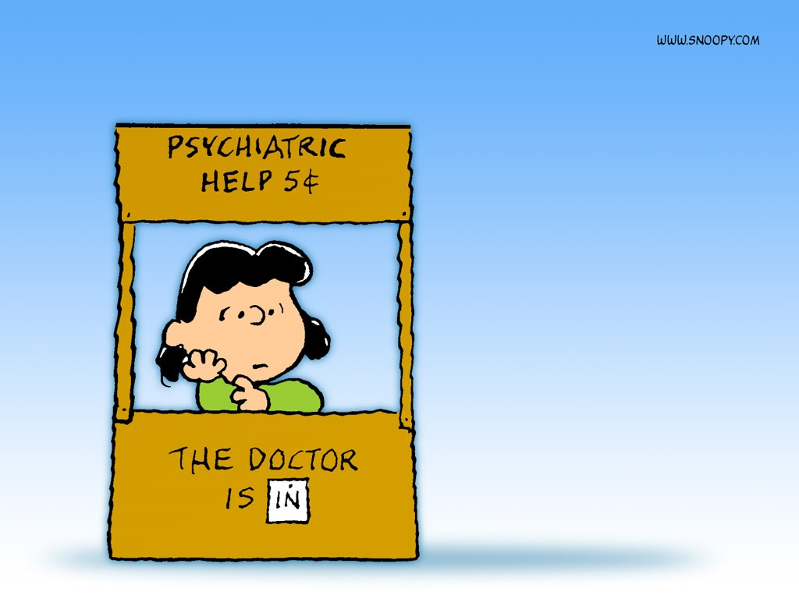

As always, thank you for allowing me the privilege of serving as your child’s counselor at AES. I am always available to talk with students or parents as you have need. Please contact me at school at 823-5921 or kaldridge@overtoncountyschools.net.

Mrs. Kerri Aldridge,

School Counselor