AES Counseling Connection

**March 1, 2017**

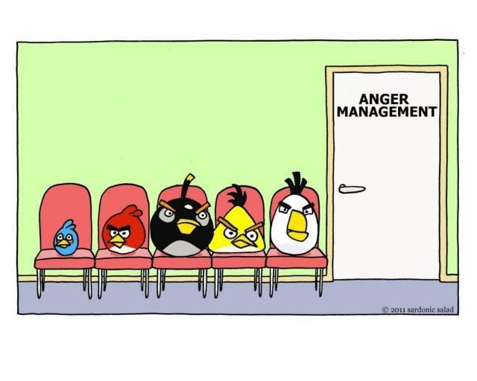

***March Lessons: Anger Management***

Dear Parents,

This month students have been studying emotions and in particular we focused on anger. Students in all grade levels have learned that anger is just an emotion and there is nothing wrong with feeling angry. It is normal and we will all feel angry at times. They have learned that it is what we do with our anger that gets us into trouble (ie.negative behavior choices lead to negative consequences).

One of the first things students learned is that our bodies are so smart at signaling us when we are getting angry. Students were asked to identify their angry cues from their bodies such as clinching fists or teeth, increase in heart rate, face turning red, etc. When we feel these warning signals that is our “red light” flashing that we need to stop and calm down before we react.

**Anger Management**

Students were also taught how to identify anger triggers. Anger triggers are things or situations that make them mad. It is very important to note that anger triggers are not people. Students were not allowed to say for example “my brother or my sister”. They had to identify the behavior that sibling did that triggered their anger. Identifying anger triggers is important so that we can possibly avoid certain situations that trigger our anger or make sure that we have a plan in place if avoiding that situation is not possible.

Students also learned the rules for anger management. As stated before, it is ok to be angry, but, students were taught that when we are angry it is NOT ok to:

1. Hurt ourselves
2. Hurt others
3. Hurt or destroy/damage property.

Effective techniques at dealing with anger were taught including:

1. Belly, balloon and bubble breathing
2. Finding a quiet spot to cool down
3. Distracting ourselves by playing a game, reading a book, watching tv
4. Exercising
5. Journaling or drawing a picture of what caused our anger
6. Listening to music
7. Sleeping or taking a nap
8. Talking to a friend or adult who can help
9. Using muscle relaxation- Robot to ragdoll
10. Laughter

[THE WEEK AHEAD]

[Lorem ipsum dolor sit amet, consectetuer adipiscing elit. Ut quam turpis, tincidunt ut, rhoncus nec, sagittis vel, erat. Morbi varius. Morbi varius tincidunt odio.

Maecenas porttitor, justo at cursus pharetra, diam enim semper mauris, vel condimentum nulla purus ac tortor.]

**Upcoming Dates to remember:**

**April 4th- 8th grade Program of study fair at livingston academy**

**april 6th at 5:30- 8th grade parent meeting at livingston academy**

**\*Students will attend the program of study fair during the school day on april 4th and parents should attend the 8th grade parent meeting on april 6th.**

**If you have questions, please contact me at school at 823-5921.**



Next month’s lessons: Careers/Test tips

Next month students will be learning about careers and the different career clusters along with testing tips as we prepare for our TN State Assessment tests in April.

Thank you for the privilege of working with your child both in the classroom setting and individually as needed.

If you have questions or need to contact me, please don’t hesitate to do so.

Sincerely,

Mrs. Kerri Aldridge

School Counselor