AES Counseling Connection

**November 1, 2017**



***Monthly Counseling Focus***

Dear Parents,

Although October is officially bullying prevention month, we spent October finishing up our lessons on respect and also celebrating Red Ribbon week. Thank you for your help in allowing your student to participate in our Red Ribbon Week celebration by dressing up for our theme days. We had a lot of fun celebrating a drug free life and future! Remember, your future is key-so stay drug free!

November brings a new topic to our counseling lessons. We are addressing the hot topic of bullying. Most importantly, students are learning what bullying is and what it is not. Often times, mean and rude behavior gets labeled as bullying when it happens only once. Bullying must follow what we call the RIP definition to be considered true bullying. It must be R-repeated, I-have an imbalance of power, and P- be done on purpose. When these three components are present, then we have a bullying situation.

Students will be receiving lessons on the bullying triangle and groups that can be involved in a true bullying situation as well as how they can prevent bully problems as a participant in each part of the triangle.

**continued**

Several years ago, our school system adopted a county wide bullying curriculum. That means that whether a student attends AES or any other county school, they will receive the same lessons on bullying. This is especially important so that all Overton County students receive the same instruction on the topic of bullying. We use books, movies and other materials in this curriculum. Should you ever have any questions regarding the curriculum, please do not hesitate to contact me.

Along with bullying, we are going to study the character trait of trustworthiness. Trustworthiness is defined as the ability to be relied on as honest and truthful. Trustworthiness also includes keeping promises and being dependable. Encourage your child to always be truthful and honest in words and actions. I often remind our students that the consequences of your negative choices will be much less if you are honest about what we have done from the beginning. You play an important role in helping your child develop these character traits. I appreciate your help in reinforcing these at home.

**[**REMINDERS]

Our Thanksgiving dinner is Friday, November 3rd. Veterans Day program is Thursday, November 9th. There is no school on Friday, November 10th in observance of Veterans Day. Thanksgiving Break is November 22-24.

Tips for Parents on Bullying

Here are some links that provide good tips for parents on dealing with the issue of bullying.

<http://www.safeschools.info/content/BPParentGuide2014.pdf>

<http://www.scholastic.com/parents/resources/collection/bullying-teasing/parent-guide-to-bullying>

<http://d3n8a8pro7vhmx.cloudfront.net/themes/51e1be8f9670a42080000002/attachments/original/1377636627/3.PreventionandInterventionTipsforFamilies.pdf?1377636627>

<http://d3n8a8pro7vhmx.cloudfront.net/themes/51e1be8f9670a42080000002/attachments/original/1377636619/2._10TipsforParents.pdf?1377636619>

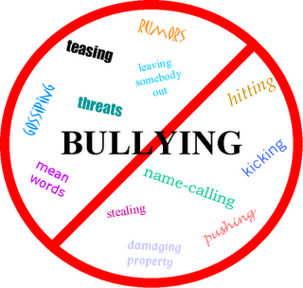

Bullying Stops Here!

Thank you for helping us do our part to educate our students and families on bullying prevention. Again, if you have any questions or I can be of further assistance, please let me know. Thank you for the privilege of working with your child!

Kerri Aldridge,

AES School Counselor

931-823-5921

kaldridge@overtoncountyschools.net