AES Counseling Connection

**October 1, 2016**



***Red Ribbon Week***

Parents,

October is the month that we celebrate making healthy choices for our bodies by not putting drugs or alcohol into them. We will be celebrating Red Ribbon Week Oct. 24-28. There will be theme dress up days each day of that week for all grade levels. Some teachers choose to give extra credit to their students if they participate. Please encourage your child to participate and help us celebrate health living during Red Ribbon Week.

Dress Up Days:

Monday: Team Up Against Drugs (wear team jerseys)

Tuesday: We Elect to Be Drug Free (wear red, white and blue)

Wednesday: Drugs are Despicable (Dress like a minion)

Thursday: Wild About Being Drug Free (crazy hair or animal print)

Friday: Cuddle Up to a Drug Free Life (wear pjs and bring a stuffed animal-must fit in backpack)

**Bullying**

October is also the month that I present bullying lessons to the students during their classroom counseling time. There is always an increase of student reports of bullying incidences after these lessons are presented. However, after investigation we find that most of these are normal conflict situations rather than instances of true bullying. Please note it is very important to know the difference between the two. Below is a link to a power point that I created that highlights the differences between conflict and true bullying. Please review this and if you have questions, feel free to contact me.

C:\Users\kerrialdridge\Documents\BULLYING VS NORMAL CONFLICT Aldridge.ppt

Students are taught this lesson as well as lessons on the bullying triangle and how to respond if you are a target or bystander in a bully situation.

Warning Signs That Your Child May Be a Victim of Bullying. Your Child May: ●Come home with torn, damaged, or missing pieces of clothing, books, or other belongings. ●Have unexplained cuts, bruises, and scratches from fighting. ●Have few, if any, friends with whom he or she spends time. ●Seem afraid of going to school, walking to and from school, riding the school bus, or taking part in organized activities with peers (such as clubs or sports). ●Take a long, "illogical" route when walking to or from school. ●Lose interest in school work or suddenly begins to do poorly in school. ●Appear sad, moody, teary, or depressed when he or she comes home. ●Complain frequently of headaches, stomachaches, or other physical problems. ●Have trouble sleeping or frequent bad dreams. ●Experience a loss of appetite. ●Appear anxious and suffer from low self-esteem.

What To Do If Your Child Is Being Bullied:

When children are involved in bullying, it is important for parents to be willing to take action. Children often do not tell their parents that they are being bullied because they are embarrassed or frightened. If you suspect you child is being bullied or your child brings it up, consider these steps:

● Talk with your child. Focus on your child. Express your concern and make it clear that you want to help.

● Empathize with your child. Say bullying is wrong, that it is not their fault, and that you are glad they had the courage to tell you about it.

● Work together to find solutions. Ask your child what they think can be done to help. Reassure them that the situation can be handled privately.

● Document ongoing bullying. Work with your child to keep a record of all bullying incidents. If it involves cyber bullying, keep a record of all messages or postings.

● Help your child develop strategies and skills for handling bullying. Provide suggestions for ways to respond to bullying, and help your child gain confidence by rehearsing their responses.

● Be persistent. Bullying may not be resolved overnight.

● Stay vigilant to other possible problems that your child may be having. Some of the warning signs may be signs of other serious problems. Share your concerns with a counselor at your child's school.

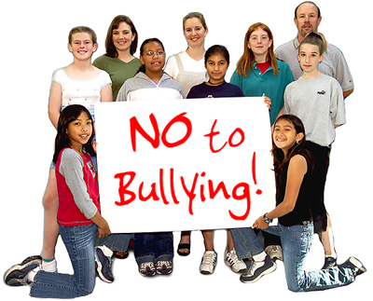

Ways to start a conversation about bullying with your child.

● Do you know what bullying is? ● Are there any bullies in your school? ● Have you ever seen anyone be bullied? What was that like for you? How did it make you feel? ● Is anyone at school mean to you? ● Does anyone at school leave you out of activities? ● Have you ever wanted to stay home from school because of the way someone was treating you? ● Who are your friends at school? Tell me about what makes them so special to you.

As always, thank you for partnering with me to help your child succeed in every aspect of their lives.

Sincerely,

Mrs. Aldridge