AES Counseling Connection

**September 1, 2016**

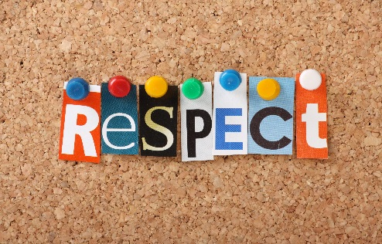

***Monthly Character Trait***

Definition: Showing high regard for self, others and property.

Respect includes: cooperation, listening to understand others and mutual support. Treating others with honor and dignity.

Related Words or Phrases ✦ appreciation ✦ honor ✦ consideration ✦ be mindful ✦ Think highly of

What does Respect Look Like? ✦ Treating others the way you want to be treated. ✦ People waiting their turn. ✦ Taking care of your school. ✦ Accepting others for who they are. ✦ Looking up to someone

Parent Connection Discussion Starters with your child:

• How can you respect other students?

• How can you respect your teachers?

• What are some good manners you can use during meal time?

• What would happen to bullying if everyone showed respect to each other?

• How does it feel if someone shows disrespect?

Students Pledge: I will…

1. Value others.

2. Respect differences

3. Use good manners

4. Not bully or bother others

5. Treat people the way I want to be treated.

What does Respect Sound Like?

Excuse me.

Thank you!

No, thank you.

Hello, how are you, today?

Please.

Kind cheerful voices.

Respect Quotes

“Without feelings of respect, what is there to distinguish between man from beasts”

`Confucius

“Be the person you would like to have as a friend.” `Unknown

“Kindness and respect for others helps grow trust.” `Donna B. Forest

“The forest would be silent if only the most talented birds sang.” `Unknown



Food for Thought

Tune your ears to the sound of respect and disrespect: Sometimes parents fail to recognize the sounds of their child’s disrespect because they may be focusing too much on the content of what is said and not listening to the child’s tone of voice. A raised voice is not necessarily a sign of disrespect, but attacking, intrusive, sarcastic, and mean words and tone are.

Be firm but keep your cool: Confident parenting is almost always clam, clear, focused, and assertive in times of conflict. `Wiliam Doherty. “Take Back Your Kids.” Excellence and Equity, Winter of 2013