AES Counseling Connection

**September 1, 2017**

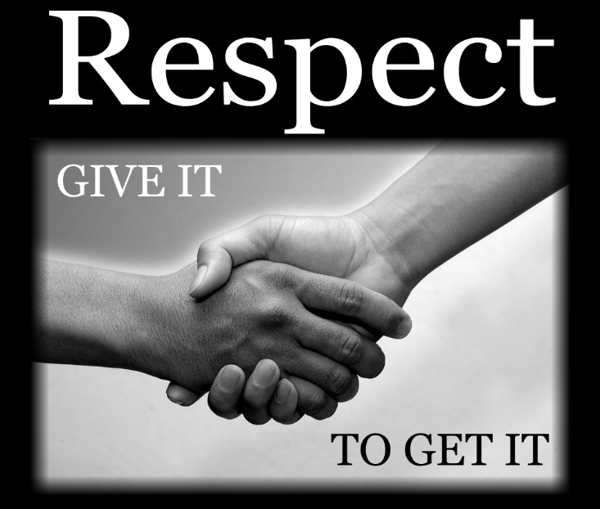

***Our theme for the month!***

Dear Parents,

This month in our classroom counseling lessons we will focus on Respect. Our first lessons in Respect will deal with self-respect. All students, grades K-8 will be participating in lessons on personal hygiene and respect for our bodies by keeping them clean.

We have already experienced illness at our school that has caused several students to be absent, so, I wanted to teach cleanliness and hygiene with a focus on bathing/showering and washing hands. Students will all be taught proper handwashing techniques and given the opportunity to practice after receiving “glitter’ handshakes in class. This is a very eye-opening hands on learning experience that taught them all how quickly germs can spread.

We will also do respect lessons on self-esteem or learning to feel good about ourselves. Students will understand what self-esteem is and how not only the words and actions of others but also thoughts and behaviors they have themselves can

**Continued**

can affect their self-esteem.

Finally, we will spend several lessons talking about how to show respect to others from authority to friends and even those who are different than we are whether from a different culture, race, religion, etc. We may not always agree with others but we can treat people respectfully despite our differences.

If you have questions or concerns about any lessons this month, please feel free to contact me.

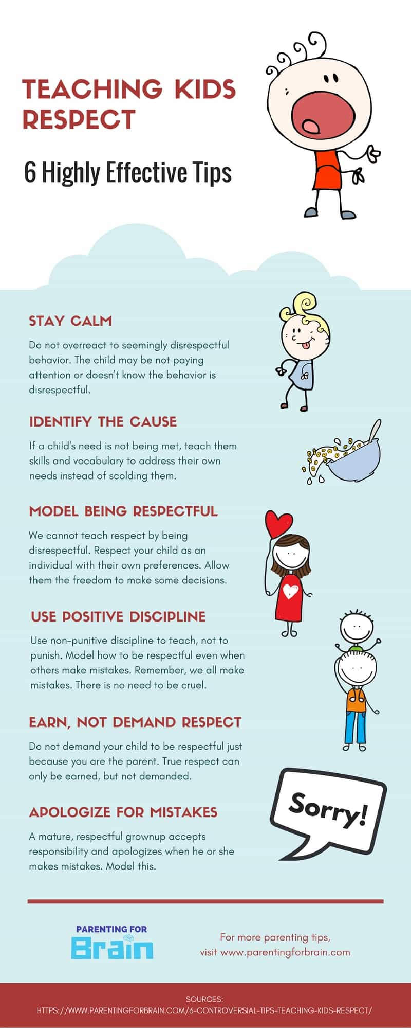



Reminders

* Picture day is september 7
* we have an ongoing character education book scavenger hunt in the library for a prize
* monthly coloring contest for grades k-4 on focus character trait

Thank you for the opportunity to serve you and your child. Please contact me anytime.

Sincerely,

Mrs. Aldridge

823-5921