AES Counseling Connection

**January 1, 2019**



Dear Parents,

Can you believe that we have turned the page to a new year on our calendars? The first half of school has gone by quickly! As we enter a new year, it is always a good time to reflect on accomplishments from the previous year and goals that we would like to achieve in the new one. In counseling class, we will spend the first part of the new year working on setting goals and learning to make good decisions. 8th grade will begin their college and career planning lessons to prepare them for high school registration in the spring.

Here are some tips for setting goals:

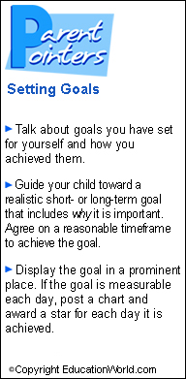

Monthly Topics for counseling class:

January: Goal Setting/Decision Making

February: Career Exploration

March: Fairness/Bullying

Important Dates to remember:

Jan. 14-15 Vanessa Farris here for 1-1 College planning for 8th grade

March 7: Parent/Teacher COnferencees 3:00—5:00

march 8: Hawk Walk

March 8: 8th grade Career Summit at

CHEC- Cookeville

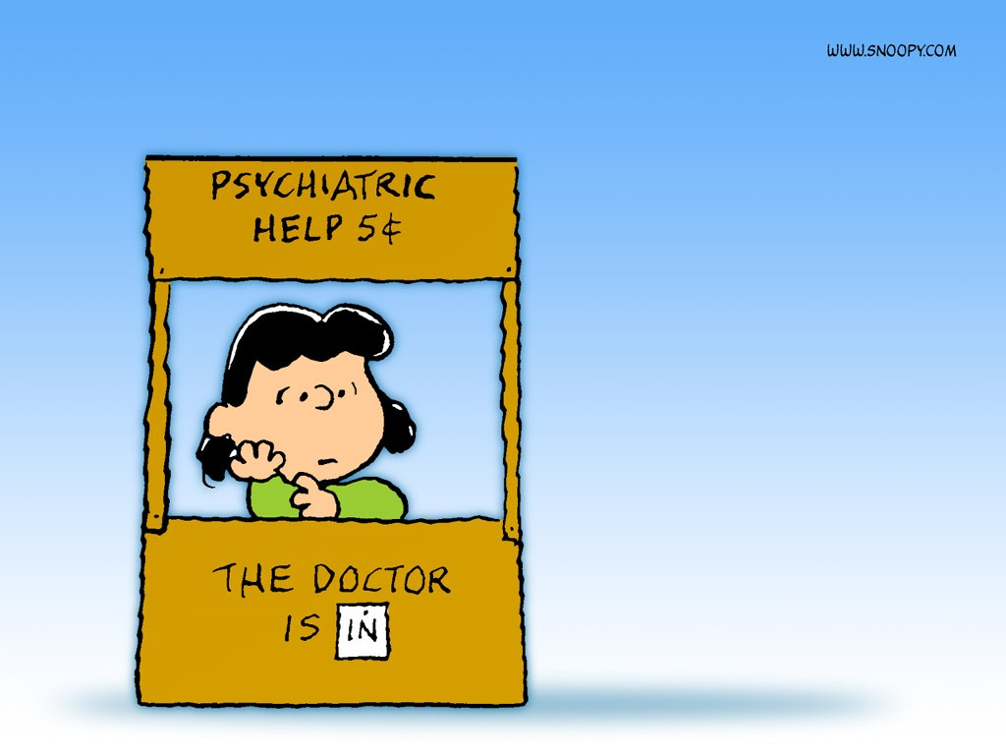

As always, thank you for allowing me the privilege of serving as your child’s counselor at AES. I am always available to talk with students or parents as you have need. Please contact me at school at 823-5921 or kaldridge@overtoncountyschools.net.

Mrs. Kerri Aldridge,

School Counselor